Women as Major World Leaders
Golda Meir
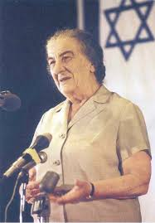

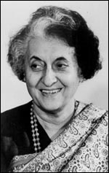
Indira Ghandi

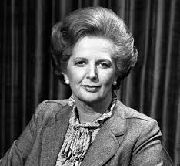
Margaret Thathcher

Biographical Info Accomplishments Policies

