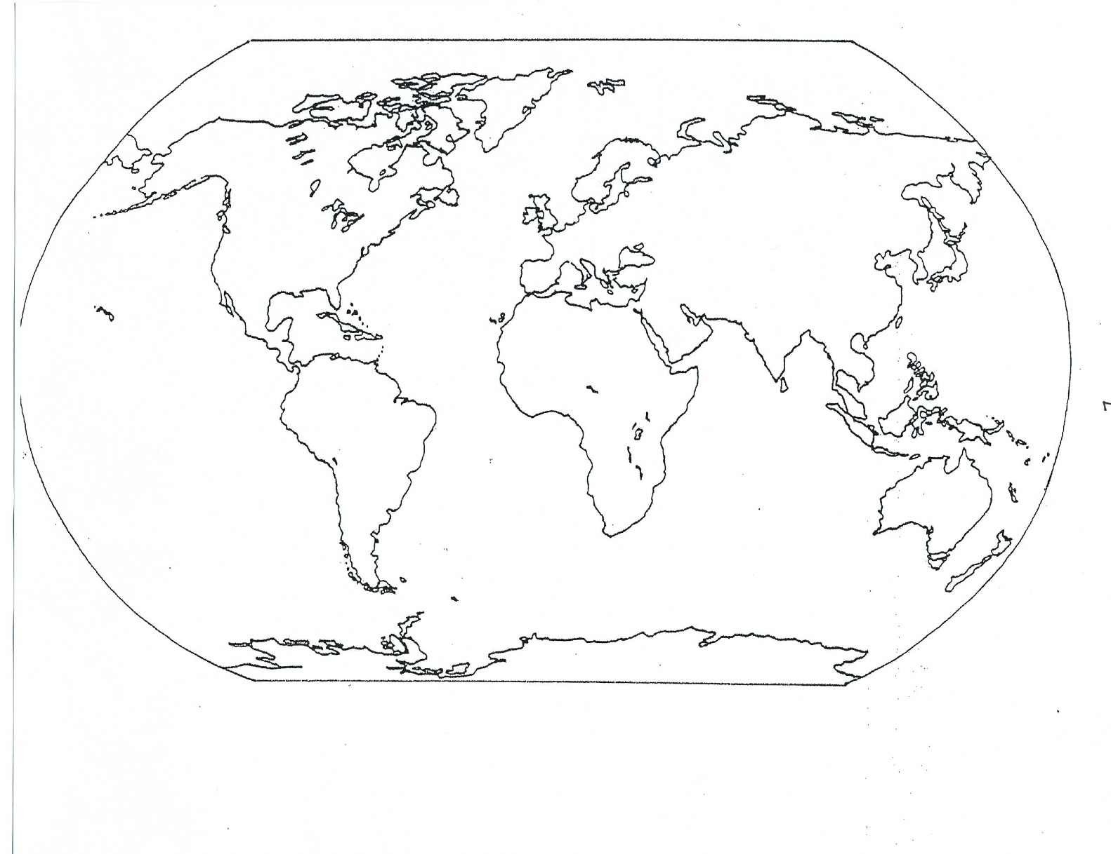

Ancient Civilizations Map

**Map Key**

Mesopotamia Egypt Indus Valley

Huang He/Yellow River Olmec Bantu Migration

***Bold Lines are Rivers***

8

soldi

8s

**Map Key**

Judaism Christianity Hinduism  Confucianism

Zoroastrianism Islam Buddhism Taoism/Daoism

***Bold Lines are Rivers***

8

soldi

8s

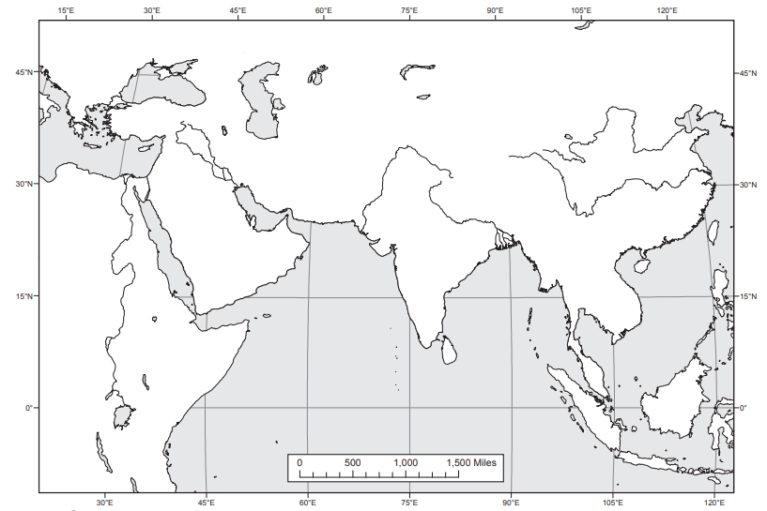

**Origins of Religions**