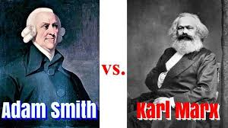
Economist | Adam Smith | Karl Marx
Major Work
Economic Philosophy
How Economic Philosophy Works

