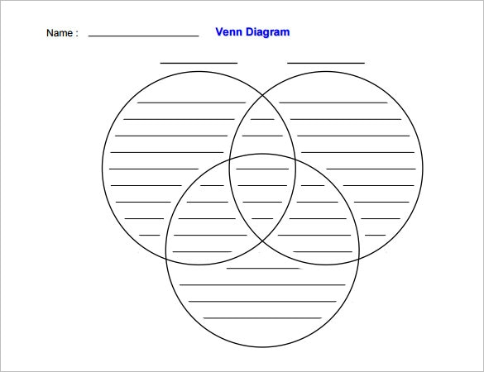
Aztec, Maya, & Inca
Compare/Contrast

