Enlightenment Thinkers

Philosopher Famous Work Main Ideas
Locke
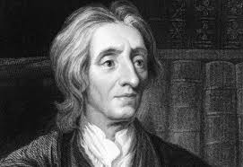
Voltaire
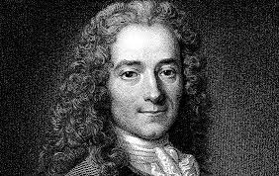
Rousseau
