The First Civilizations Emerge on the World Stage
During the same sliver of cosmic time, cities, states, and civilizations emerged independently in several places around the world.
The first agrarian civilizations developed in about 3200 BCE. These early farming societies started in three areas: Mesopotamia; in Egypt and Nubia (now northern Sudan); and in the Indus Valley. More appeared in China a bit later and in Central America and along the Andes Mountains of South America at about 2000–1000 BCE. Why and how did this occur?
To have a meaningful discussion, let's define the words "city," "state," and "civilization." A "city," with tens of thousands of people, is larger than a town which contains only thousands of people. A village is made of just hundreds. In cities, people work in specialized jobs, instead of being farmers. Their food is grown by farmers nearby.
A "state" is a city, or several cities, plus surrounding villages and farms. A state could include hundreds of thousands of people, even millions. It would have political, social, and economic hierarchies, with a few elite people at the top. Elites typically make up no more than 10 percent of the population, and have more wealth and power than the remaining 90 percent. States were ruled by elites who exercised the right to use force, if necessary, to keep order and collect taxes or tribute.
Out of states arose empires, in which a single ruler controlled large territories of cities and farmland. These large states are often called "civilizations." This word has previously been used to imply superiority or advancement; historians now try to use it simply to mean that civilizations share certain characteristics.
All civilizations have dense populations and are controlled by elites. This does not mean they are better than other kinds of societies, but they are, by definition, more complex. Since these early civilizations always depended on the farming around them, we call them "agrarian civilizations."

Places of early civilizations
Four of the earliest agrarian civilizations occurred in fertile river valleys. They used as their foundations plants and animals that had been domesticated earlier.
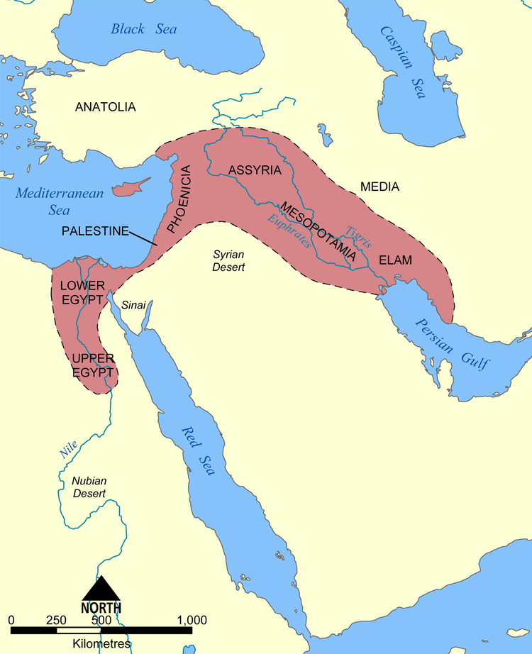
The first of these formed in Mesopotamia, in what is now Iraq. What made this area so fertile was the land between the Tigris and Euphrates rivers. The valleys of these rivers had no large trees, no big stones, and no metals. But, with irrigation, people could grow large crops of wheat and barley, grasses that had been domesticated earlier in the mountains nearby. They also grew lentils and chickpeas and herded sheep and goats.
The next three places where agrarian civilizations emerged were in the Nile River Valley in Egypt and Nubia, the Indus River Valley in India, and the Huang He (Yellow) River Valley in China. Each river valley had its own distinctive plants and animals, which had been domesticated nearby. The Egyptians and Nubians had wheat, barley, cattle, fish, and birds. The Indus Valley people raised cattle and cotton, as well as wheat, barley, lentils, sheep, goats, and chickens. In China, wheat was grown in the north, with rice cultivated later in the south. Pigs, chickens, and soybeans also formed the staple foods in China.
Large states emerged a couple of thousand years later in the Americas, where the food options were quite different. People in Central America domesticated maize (corn), peppers, tomatoes, squash, beans, peanuts, and cotton. Their only domestic animals were dogs and turkeys. Along the Andes Mountains in South America, people used llamas and alpacas for wool and transportation; for food they depended mostly on potatoes and quinoa, a grain rich in protein. They had guinea pigs, and fish brought up from the coast, where seafood had supported earlier dense coastal populations.

Why and how did states emerge?
After people learned to domesticate plants and animals, they gradually learned to utilize animals for a variety of things. Instead of eating animals right away, they used them for their milk, wool, manure, and muscle power. The increased cultivation and development of available resources caused the world's population to grow dramatically. In 8000 BCE, it stood at perhaps 6 million. By 3000 BCE, it was maybe 50 million.
At the same time, the climate was changing dramatically. The Earth had reached a stable level of warmth by about 8000 BCE. It had been gradually warming since the height of the last Ice Age, which was about 20,000 BCE. After 8000 BCE, the climate in the northern hemisphere generally became drier, as the monsoon belt shifted southward (possibly due to slight changes in the Earth's orbit). This dryness drove people from upland areas down into river valleys, where access to water was more certain. Floods deposited rich soil in these valleys, helping them to produce abundant food.
As density and food surpluses increased, the social structure changed. A small part of the population became much wealthier and more powerful than the rest. Why did the majority of people allow this to happen? We can only guess that people needed leadership to manage projects like large-scale irrigation or distributing surplus food. They also needed armed protection against neighboring groups. At the same time, ambitious priests and rulers could take opportunities to control the food surpluses to increase their own power. Gradually, they were able to formalize their power, forming political or religious groups that held significant control over the land and its people.

Areas without early civilizations
Some areas of the world did not produce full-blown cities and states early on. Even so, the trend toward agriculture seems to have been present everywhere.
In sub-Saharan Africa, people were separated from the northern coast by the harsh desert. Rain forests covered much of the land, with lots of tropical diseases. The Bantu people, in the eastern part of modern Nigeria, cultivated yams, oil palm trees, millet, and sorghum and herded cattle. Eventually, camels replaced horses and donkeys for travel across the Sahara. Muslim merchants could now make their way across the desert to the west coast. Small regional states and kingdoms emerged, but never a major agrarian civilization.
Small islands in the Pacific did not have the resources to create full-scale agrarian civilizations, but their smaller states and chiefdoms had features similar to those around the world. In Australia, agriculture never really materialized. Soils were poor, and the island was isolated. New evidence suggests that trends toward the development of agriculture might have continued had European colonists not arrived.
Archaeologists have long thought that the basin of the Amazon River didn't contain the resources to support dense human societies. But recent evidence suggests that people there found ways to fertilize the soil by adding charcoal. The rain forests there today may even have once been orchards that supported large populations.

Comparing early agrarian civilizations
All of the earliest agrarian civilizations developed many similar characteristics beyond the defining ones of hierarchical force and coerced taxation or tribute. It seems that only centralized state control can effectively integrate and support large populations of people.
Other common characteristics of civilizations include the following:
—Storage of surplus food
—Development of a priestly class; a state religion based on supernatural gods/goddesses
—Central authority (such as a king, pharaoh, or emperor)
—Specialized occupations and division of labor
—Social divisions based on wealth, ancestry, and occupation
—Increased trade
—Systems of writing or recording information; increased collective learning
—Standing armies; increased warfare
—Monumental public architecture (such as temples or pyramids)
—Increased inequality between men and women; patriarchy
Despite all these similarities, early civilizations differed significantly. Perhaps most importantly, the civilizations in northern Africa and Eurasia were connected with each other soon after they began. Together they formed an Afro-Eurasian zone where people traded goods and exchanged ideas and technology. Connecting roads went east-west through similar latitudes, and there were sea routes between numerous ports.
In contrast, early civilizations in the Americas were hardly connected at all. They had fewer kinds of transport animals. Fewer routes existed over difficult terrain that separated the north-south changes in latitude. This difference would prove important when sailors from Europe arrived on the shores of the Americas with horses, guns, and steel swords. They also carried with them germs they had picked up from their domestic animals to which they became immune. The Europeans' animals and technologies were the result of collective exchanges among several early Afro-Eurasian civilizations.
Early civilizations shared many characteristics that made them successful. If we take a closer look, we can see fascinating details that made them different. All the early civilizations developed some form of writing — except the Inca in the Andes. They instead used a system of tying knots in different colored string, called quipu, to record their transactions and possibly even their stories. All early civilizations engaged in warfare — except, perhaps, in the Indus Valley. Some arrowheads and spears have been found there, but no swords, helmets, shields, or chariots.
Every civilization with writing started by using pictographs but switched to some form of alphabet — except the Chinese. To this day, they still use pictographs in their writing. Every civilization practiced human sacrifice, but the Aztecs used it on a much larger scale than others. They believed that the world would end if the chief god did not receive his daily offering of human blood to keep the Sun shining. While early civilizations shared many common features, the differing details form a mosaic of human culture.

