Louis XIV of France Peter the Great of Russia
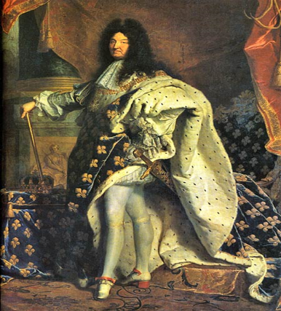 | 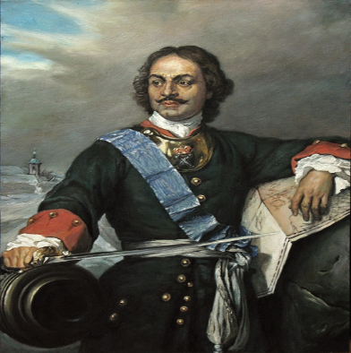
Centralized Government | Centralized Government
Eliminated Competition | Eliminated Competition
Controlled Landowning Masses | Controlled Landowning Masses
Controlled Religion | Controlled Religion
New Capital | New Capital

